NAME : Sharvayu Zade
SEC: B(B2)
PRN: 23070521135

Practical 5
Part1: Array Basics in JavaScript
What is an Array?
An array is a data structure that can hold multiple values in a single variable. In JavaScript, arrays can contain numbers, strings, objects, or even other arrays.
Syntax:
let arrayName = [element1, element2, element3, ...];
Common Array Methods
push(value) → Adds a new element to the end of the array.
pop() → Removes the last element of the array.
length → Returns the number of elements in the array.
Higher-Order Function: map()
The map() method creates a new array by applying a function to each element of the existing array.
Does not modify the original array.
Syntax:
let newArray = array.map(function(element) {
return operation(element);
});
Example Steps
Create an array with 5 numbers.
Use push() to add a number to the array.
Use pop() to remove the last number.
Display the length of the array using length.
Use map() to calculate and print the square of each number.
Program
// Step 1: Create an array with 5 numbers
let numbers = [2, 4, 6, 8, 10];
console.log("Original Array:", numbers);
// Step 2: Add a new number using push() numbers.push(12);
console.log("After push(12):", numbers);
// Step 3: Remove the last number using pop() numbers.pop();
console.log("After pop():", numbers);
// Step 4: Print the length of the array console.log("Array length:", numbers.length);
// Step 5: Use map() to get squares of numbers let squares = numbers.map(num => num * num); console.log("Squares:", squares);

Sample Output
Original Array: [2, 4, 6, 8, 10]
After push(12): [2, 4, 6, 8, 10, 12]
After pop(): [2, 4, 6, 8, 10]
Array length: 5
Squares: [4, 16, 36, 64, 100]

Sum of numbers 10 number take input using for loop
Tasks part 1:
Create an array of student ages and use push() to add a new age. Use pop() to remove the last age and display the array. Print the length of the array.
Use map() to calculate double of each age.
Challenge: Use map() to find the cube of each element.
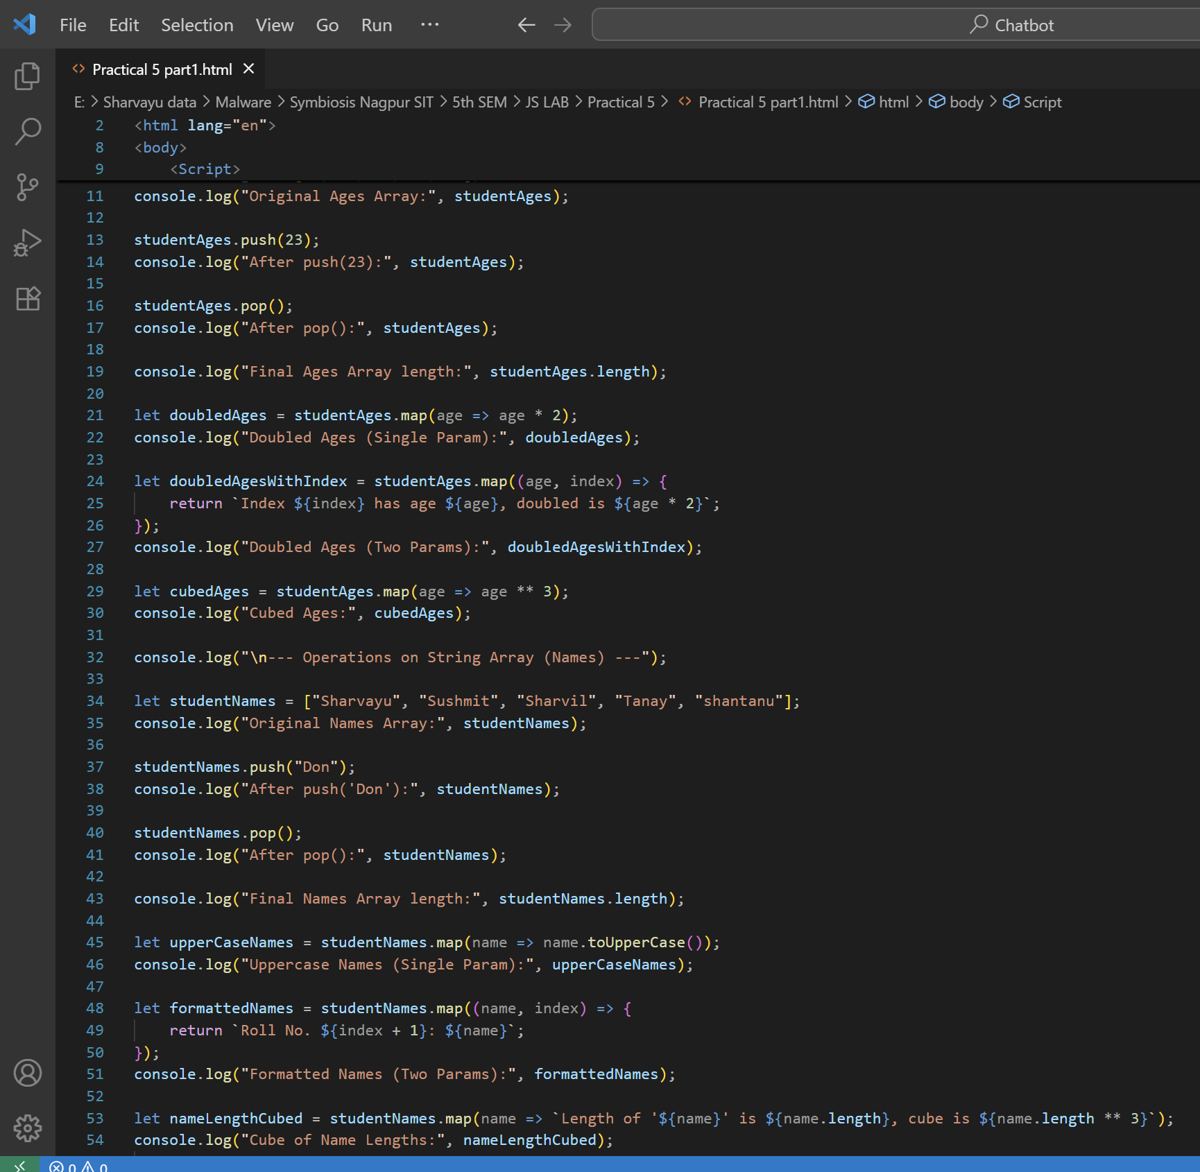
Part2: Objects
What is an Object?
An object stores data as key–value pairs.
Keys are called properties, and values can be numbers, strings, arrays, or even functions. Syntax:
let objectName = {
key1: value1,
key2: value2,
key3: value3
};
Array of Objects
An array of objects is useful for storing multiple structured items (like products, students, employees).
Example:
let products = [
{ id: 1, name: "Pen", price: 20 },
{ id: 2, name: "Notebook", price: 50 }
];
Useful Methods
map() – Extract or transform object properties.
filter() – Select specific objects based on conditions.
forEach() – Loop through each object for printing/display.
Example Steps
Create an array of objects representing products.
Use map() to print only product names.
Use filter() to select products belonging to a specific category.
Use reduce() to calculate the total price of all products.
Use forEach() to display product details in a formatted way.
Program
// Step 1: Create an array of objects
let products = [
{ id: 1, name: "Pen", price: 20, category: "stationery" }, { id: 2, name: "Mug", price: 150, category: "kitchen" }, { id: 3, name: "Notebook", price: 80, category: "stationery" },
{ id: 4, name: "Marker", price: 50, category: "stationery" } ];
// Step 2: Use map() to get all product names
let productNames = products.map(item => item.name);
console.log("Product Names:", productNames);
// Step 3: Use filter() to get only stationery products let stationeryItems = products.filter(item => item.category === "stationery");
console.log("Stationery Items:", stationeryItems);
// Step 4: Use reduce() to calculate total price
let totalPrice = products.reduce((sum, item) => sum + item.price, 0); console.log("Total Price of Products:", totalPrice);
// Step 5: Use forEach() to print product details
console.log("Product List:");
products.forEach(item => {
console.log(`${item.name} - ${item.category} - $${item.price}`); });
Sample Output
Product Names: [ 'Pen', 'Mug', 'Notebook', 'Marker' ] Stationery Items: [
{ id: 1, name: 'Pen', price: 20, category: 'stationery' }, { id: 3, name: 'Notebook', price: 80, category: 'stationery' }, { id: 4, name: 'Marker', price: 50, category: 'stationery' } ]
Total Price of Products: 300
Product List:
Pen - stationery - $20
Mug - kitchen - $150
Notebook - stationery - $80
Marker - stationery - $50
Tasks part2:
Create an array of objects for students with properties: { id, name, marks }. Use map() to extract all student names.
Use filter() to select students with marks > 50.
Use reduce() to calculate the average marks.
Use forEach() to print a report card format.